Microsoft Dynamics CRM SDK
Custom Price Plug-in Sample Readme

Installation instructions
You can install the plug-in by using the Microsoft Dynamics CRM solution that contains the plug-in or by building the plug-in sample project and then registering it by using the Plugin Registration tool. It is strongly recommended that you register the sample plug-in on a non-production server.

Import the CRM solution
Import the SampleCalculatePricePlugin_1_0_0_0_managed solution to your CRM organization. After the solution is imported successfully:
- The CalculatePrice.PlugIn is registered in your CRM organization.
- The Use system pricing calculation setting in the Sales tab (Settings > Administration > System Settings > Sales tab) is set to No.

Build the plug-in sample project

Open the plug-in project and build the plug-in sample assembly
- Load Plug-ins.sln into Visual Studio 2013.
- In Visual Studio, build the solution by choosing Build > Build Solution or by pressing F6.

Register the assembly and plug-in
- Start the Plugin Registration tool, which is available in the SDK\Tools\PluginRegistration folder.
- Choose Create New Connection.
- In the connection dialog box, type your Microsoft Dynamics CRM server information and credentials to connect to.
If you have access to multiple organizations and want to select the organization where you want to register the plug-in, select the Display list of available organizations check box, and click Login.
- If you have multiple organizations, select the organization that you want to connect to, and click Login.
- In the tool, choose Register > Register New Assembly.
- In the Register New Assembly form, choose the ellipses (…) button under Step 1: Specify the location of the assembly to analyze, navigate to the bin\Debug folder of the plug-in project, and select the plug-in assembly: CalculatePrice.PlugIn.dll.
- Verify that the Select All, Sandbox, and Database check boxes are selected. Click Register Selected Plugins.
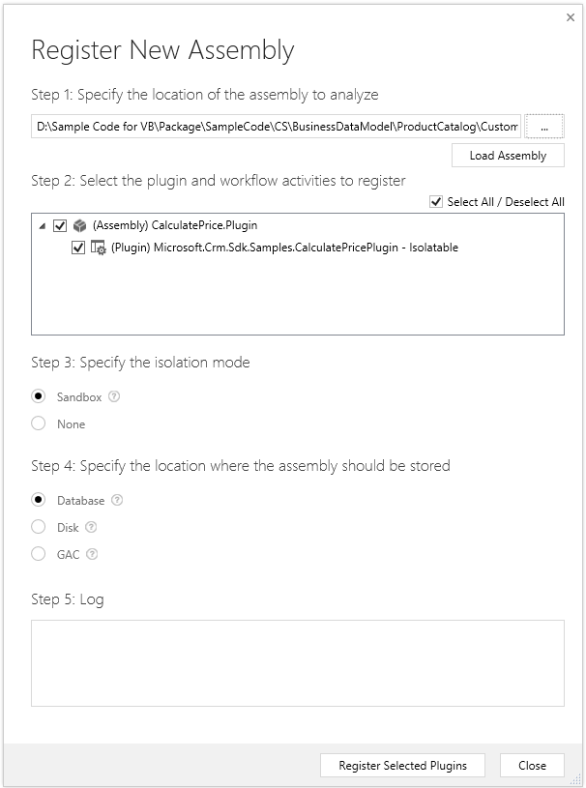
- A message appears confirming the registration of your plug-in assembly. Choose OK.
- In the Registered Plugins & Custom Workflow Activities tree view, select the plug-in type, for example, Microsoft.Crm.Sdk.Samples.CalculatePricePlugin.
- Choose Register > Register New Step.
- In the Register New Step dialog, enter the registration parameters as instructed to in the plug-in code comments. For example:

Message: CalculatePrice

Event Pipeline Stage of Execution: Post-Operation

Execution Mode: Synchronous

Deployment: Server
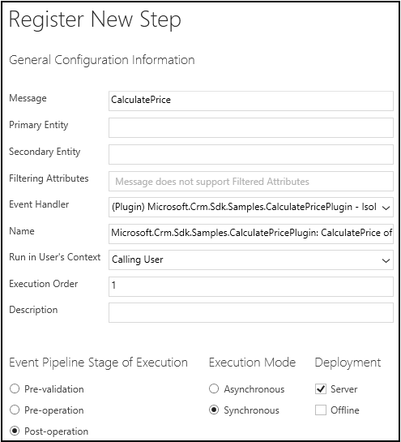
- Choose Register New Step.

The plug-in is now registered. You can close the tool.

Testing
To test the CalculatePricePlugin plug-in, follow these steps.
- Ensure that the Use system pricing calculation setting in the Sales tab (Settings > Administration > System Settings > Sales tab) is set to No.
Create and save a new opportunity in Microsoft Dynamics CRM. Open the opportunity’s form, and add some write-in products. Specify the product unity value and quantity for each product line item, and observe the prices.
The discounts and taxes are calculated based on the total amount of all the product line items in the opportunity:
- Discount: If the total amount is greater than 1000 and less than 5000, the discount is 5%. If the total amount is 5000 or greater, the discount is 10%.
- Tax: Tax is applied on the amount that is effective after the discount is applied (total amount minus discount). If the effective amount is less than 5000, tax is 10%; otherwise, the tax is 8%.

Important notes
The sample files are not intended to be used in a production environment. You should deploy this sample to a test environment and examine it for interaction or interference with other parts of the system.

Copyright
This document is provided “as-is”. Information and views expressed in this document, including URL and other Internet Web site references, may change without notice.
Some examples depicted herein are provided for illustration only and are fictitious. No real association or connection is intended or should be inferred.
This document does not provide you with any legal rights to any intellectual property in any Microsoft product. You may copy and use this document for your internal, reference purposes.
© 2014 Microsoft Corporation. All rights reserved.
Microsoft, Internet Explorer, Microsoft Dynamics, Visual Studio, and Window are trademarks of the Microsoft group of companies. All other trademarks are property of their respective owners.

